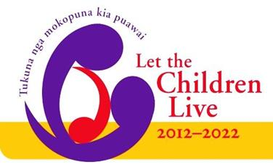

Are you looking to
Be Even More Relevant to the Needs of Children?
Try Something New
Or perhaps you have a good initiative already
but need some finance to take it to the next level?
If your answer is yes, then read on….

The ‘Let the Children Live’ - Funding Parish Initiatives are still available,
with 10 grants available every quarter. The maximum grant is $600.
It is available for Methodist parishes, Rohe and Co-operating Ventures of which the Methodist Church is a partner. The project needs to support or enable the church's 10 year vision 'Let the Children Live' and be based within New Zealand. If you are successful, you will prepare a story of your initiative for publishing either in Touchstone or on the Methodist website. Be realistic in what you ask, yet be prepared to take some risks to engage in the vision together.
Send us your proposal today, detailing your initiative, [no more than two sides of A4] including your Parish name, your name and contact details and the Minutes of the Parish Council/Leaders meeting approving the initiative.
Post to: ‘Let the Children Live’ – Mission Resourcing, Private Bag 11-903, Ellerslie, Auckland 1542 or email: admin@missionresourcing.org.nz
Final closing date for 2020: 3rd November 2020
Closing dates for 2021: 2nd February, 4th May, 3rd August and 2nd November 2021

