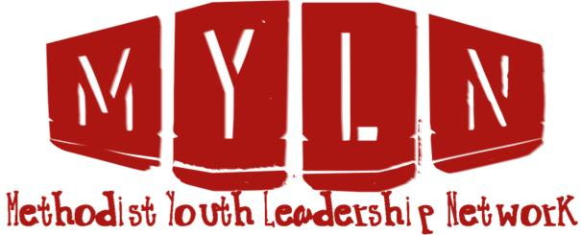

Fill in the form below to JOIN the MYLN Database
(Please note, all contact information remains confidential)
Personal Details
Name
Email
Contact Number
Parish Details
Parish Name
Children or Youth Ministry Name
Please Circle/Highlight
Group size | 1-10 11-20 21-30 30+
I require (Please check applicable)
Resources for my ministry
Training for my ministry workers
Information on upcoming events
Connection with other ministries in my area
Comments or questions
Once completed
SCAN and email to michael@missionresourcing.org.nz
OR
MAIL by sending to Private Bag 11903, Ellerslie 1542 (ATTN: Michael Lemanu)

