On
Being
Methodist

There are 70,000,000 Methodists world-wide. What makes them different from other denominations?

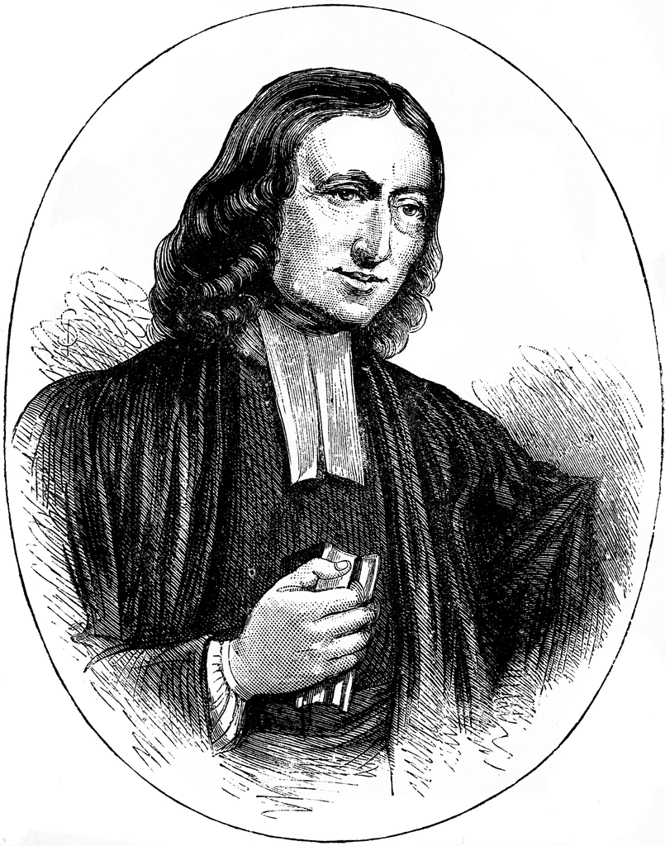
Roots
The Wesleys
John and Charles Wesley were sons of the vicarage. Their parents, Samuel and Susannah were both from Anglican backgrounds. Samuel’s father and grandfather had been ordained before him. Susannah’s father, Dr Annesley, was one of the leading non-conformist ministers in London at the time. Both parents were well-educated and they taught all their children to read and write in English, Greek and Latin. Both parents were creative and wrote poetry and music.
At Oxford University John and Charles began their journey towards the creation of the Methodist church, establishing a Holy Club of people who wanted to meet regularly for fellowship, prayer and study. They were very methodical in their practice. They visited the poor and the sick, took communion regularly and fasted twice a week.
The Wesley brothers went on to be ordained, and were invited to go to Georgia to minister in Savannah and to the ‘natives’. Things did not go well and they returned to London. A few months later, each brother had a spiritual experience, where he felt, for the first time, an assurance that God loved him and that he was saved. After spending some time with the Moravian church, they began their own societies. The Anglican Church did not accept them, so John and Charles, and the new societies preached in the open air and in their own buildings, making
thousands of converts through their enthusiasm, their singing and their challenge for changed lives. One hearer, an Anglican rector, wrote to John Wesley, “Your way of thinking is so extraordinary that your presence creates awe, as if you were an inhabitant of another world.” [Whitelamb, rector of Wroote]
The Methodist church grew out of a need to organise and formalise the new societies. Chapels were built. There was a system of membership, with tickets that were renewed every three months (if you were still worthy). The Class Meeting was established for regular meetings of small groups for prayer, study and fellowship. To organise the church, the Wesleys established a Conference to meet regularly, with John Welsey in the chair.

How and when did Methodism come to New Zealand?
Some of the first Europeans to come to New Zealand were Methodist missionaries. The Methodist emphasis on personal salvation and social responsibility both played a part in bringing the missionaries to these shores. The first mission was at Kaeo in Northland in 1823, set up by the Wesleyan Methodist Missionary Society in Britain. More missions were set up in the 1830’s and 1840’s in such places as Hokianga, Manukau, Kaipara, Kawhia, Waipa, Mokau and New Plymouth in the North Island, and Waikouaiti and Cloudy Bay in the South Island.
A Native Institution was established in 1845 to train Maori ministers to serve Maori communities. By 1858 10% of New Zealanders were Methodist (a higher proportion than in England), and by 1850 there were 22 Methodist ministers in the country.
In 1874 the church became independent of the British Conference and had its own annual Conference in New Zealand. Until 1910 this reported to the Australian Conference every three years.
Current position
The 19th and 20th centuries saw the height of popularity for the Methodist Church in New Zealand. It also exercised a strong social influence. Since then there has been a steady decline. Only 4.5% of the population were Methodist in 1981 and this dropped to 2.6% in 2013. The make up of the church has also changed from being mainly European and Maori to being 33% Pacifica by 2013.
http://www.teara.govt.nz/en/methodist-church

Thirteen things that are distinctive about Methodism

- All can be saved
This is a traditional summary of Methodist teaching.
" | All need to be saved.  All may be saved.  All may know themselves saved.  All may be saved to the uttermost."
No-one is without sin. No-one is beyond the reach of God’s love, and anyone who turns to God will be saved and can have a personal experience of God.

- Assurance of God’s love and salvation
After his experience at Aldersgate St., where he felt his heart warmed with an assurance that God had taken away his sins, John was sure that such a feeling of assurance was available to everyone. Not that the feeling was what saved you, but that you could know that you are saved – not just theoretically.
- Living a holy life
John Wesley taught about 'Christian perfection.' He believed that a mature Christian can reach a state where the love of God reigns supreme in the heart. And that one should be always working towards that state through Bible study, prayer, fellowship and social engagement.
This is why Methodists spend time in study and prayer, and why they engage in social projects with homeless, jobless and deprived people in New Zealand and abroad.

- Importance of laity
Local members take responsibility for the upkeep of buildings, care of the members, preaching the gospel etc. All Christians are ‘ministers’ in that all have a personal relationship with God and can speak directly to him and receive wisdom and guidance from him. Local members also take part in the decisions of the whole church through parish meetings and representation to Synod and Conference.

- Small groups
Class meetings originally met weekly to keep people accountable for their faith journey. They had to share what God had done in their life since this last meeting. Others could comment and encourage them, or tell them off! Methodists are still encouraged to meet for prayer and Bible study in small groups, where they can learn from each other and encourage each other to grow in the faith.

- Reading the Bible
Personal and group reading of the Bible is encouraged as a way of getting to know more about God and being inspired and directed.
God reveals himself through his word to anyone who reads it.

- The Methodist Quadrilateral
Although the Bible is the great revelation of God’s story and his will, the early Methodists were encouraged to test new ideas against the 4 wise insights:
Scripture: the inspired word of God and supreme source of insight.
Tradition: what has God done and said in the Church in the past, especially the older mainstream churches.
Reason: using the God-given intellect to test the rationality of an idea.
Experience: asking if there is evidence of the new idea in the lives of Christian people.

- The Covenant Service
Methodist churches hold an annual Covenant service where members remember what God has done in their life during the year and renew their commitment to God for the coming year. They make this prayer:
“I am no longer my own, but Thine. Put me to what Thou will. Let me be employed for Thee or laid aside for Thee. Let me be full, let me be empty. Let me have all things, let me have nothing. I freely and heartily yield all things to Thy pleasure and disposal. Thou art mine, and I am Thine.”

- Born in song
Charles Wesley wrote about 6,000 hymns, many of which are still sung today across the world, in all languages. It was known from the first that singing was a powerful way of spreading the gospel, explaining the faith and connecting people to each other. John Wesley had strong feelings about how people should sing – He wrote these instructions for the first formal hymn book:
….Sing them exactly as they are printed here, without altering or mending them at all;
Sing all. See that you join with the congregation as frequently as you can.
Let not a single degree of weakness or weariness hinder you.
Sing lustily and with good courage. Beware of singing as if you were half dead, or asleep; but lift up your voice with strength.
Sing in time. Whatever time is sung be sure to keep with it.
Above all sing spiritually. Have an eye to God in every word you sing.
It is still a moving experience to be part of a Methodist congregation singing with enthusiasm.

- Connexion
A methodist belongs to a local congregation which is part of the wider organisation, both national and international. Wesley said, “Do not allow yourself one thought of separating from your brothers and sisters, whether their opinions agree with your or not.”

- Itinerancy
This began out of the need to provide the new Methodist societies with good preachers. Mr. Wesley moved his preachers around the different circuits every year initially. One reason for this was a fear that they might become stale. Another was the desire to keep the links between the circuits and the national organisation (the Connexion) alive. Over the years, the length of stay has increased from one year to five, ten or even more.

- Society
For the Wesleys, deeds as well as faith were important in Christian life. Doing good was seen as part of the faith journey. There were two kinds of work to do: work at reading the Bible and attending church; and work at following the example and commands of Jesus to heal the sick and care for the weak. In the early days Methodists were involved in welfare projects such as caring for the poor and prisoners. Methodists have also been active in campaigns to improve the lives of the poor and disadvantaged through temperance, anti-slavery and anti-racism campaigns. This emphasis is still apparent today.
John Wesley may not actually have said, “Do all the good you can. By all the means you can. In all the ways you can. In all the places you can. At all the times you can. To all the people you can. As long as ever you can.” However, he must have intended it. The Second General Rule of the United Societies 1739 read; By doing good; by being in every kind merciful after their power; as they have opportunity, doing good of every possible sort, and, as far as possible, to all men.

And John Wesley challenged people to ask; “Not, how much of my money will I give to God, but, how much of God’s money will I keep for myself?”

- Evangelism
John Wesley said, “I look upon all the world as my parish; thus far I mean, that in whatever part of it I am, I judge it meet, right and my bounden duty to declare unto all that are willing to hear, the glad tidings of salvation.” (Journal, June 11 1739) and “You have one business on earth – to save souls.” Today we are given the same message by the World Methodist Council. “We believe that the Lord Jesus Christ’s Commission to His church to preach the Gospel and to make Disciples is the supreme business of the Church.”

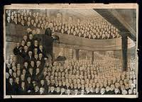

Wesley preaches to a full church.

What does all this mean for us today?
The people called Methodist trace their foundation to a group of enthusiastic Christians who were inspired by the Holy Spirit to go out into their country and preach the good news, transform lives and then nurture the newly converted. We stand in their shadow and are charged to so just the same in our own age.

