St Paul’s Putaruru
Family Day Out to the Tokoroa Pools
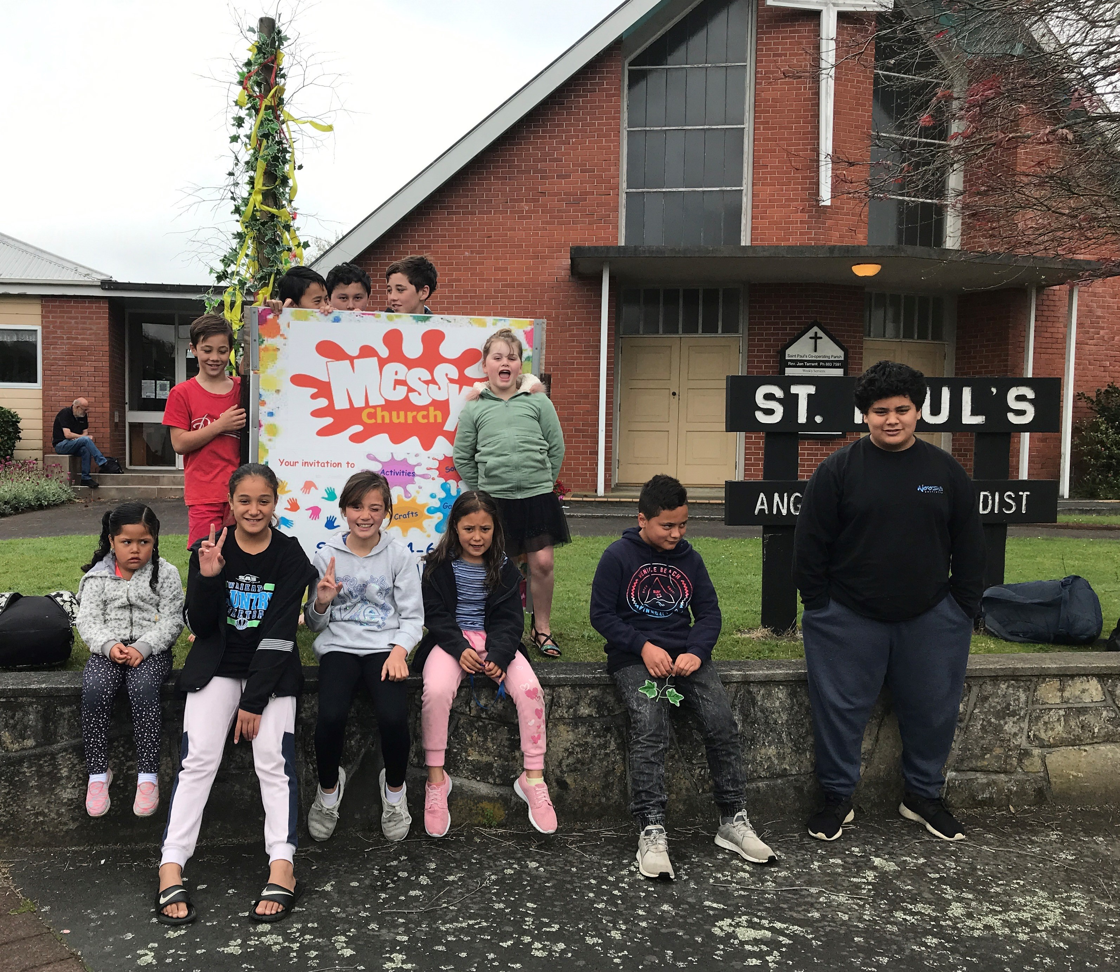
With the recent move to Level One St Paul’s Putaruru were quickly able to make the final arrangements for their 6th annual Family Day Out. They had secured the funding for the trip from the “Let the Children Live Fund” earlier in the year with the hope that the trip would be able to go ahead after the lockdown.
With the bus and pool booked, food prepared, pizza’s ordered and all the Safe Here paper work done they travelled to Tokoroa by bus and car and had a wonderful day out together. 75 people attended the outing. All the children were encouraged to bring a family member.
It was lovely to see the families having fun together in the pool.
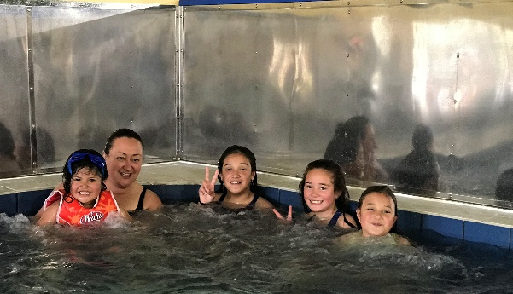
Mary Addison
Children, Family and Community Team Leader

